Rebecca Hoskins

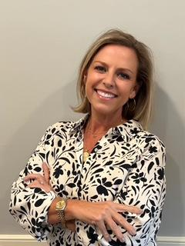

Certified Youth/Teen Life Coach
Becca grew up on the beaches of the Gulf Coast of Florida. She is a Certified Life Coach with a BA in Psychology and a heart-centered passion for supporting youth, teens and young adults as they navigate the challenges of growing, discovering who they are, and finding their place in the world.
For the past two years, Becca has served as the Office Manager at Harlow Counseling, where she has had the opportunity to work alongside counselors and families from all walks of life. This experience has pushed her desire to provide meaningful support, particularly to children, teenagers, and young adults during the important formative years of their lives.
She has always had a heart for the younger generations, but it really grew when she was in college and attended the Guardian ad Litem Academy. Her years spent as a Guardian really ignited her passion for fostering the minds of our youth.
She has spent years coaching sailing and teaching, experiences that taught her the importance of patience, encouragement, communication, resilience, and meeting people where they are. She has also spent most of her adult life supporting her husband through his military career, embracing the many transitions, challenges, and opportunities that come with military life.
As a wife and mother, Becca brings a deep personal understanding of the joys and challenges of family life. She has been married for 27 years and is the proud mother of two amazing sons--one that required an Individual Educational Plan beginning at age 3. Raising a child with special needs has further shaped her understanding of advocacy, perseverance, compassion, and the importance of seeing the whole person rather than simply focusing on the challenges they may face.
She has a genuine heart for the well-being and minds of today’s youth. She believes that children and young adults deserve to have someone in their corner—someone who will listen without judgment, recognize their strengths, encourage their growth, and help them develop the confidence and tools they need to navigate life. Her approach is warm, encouraging, practical, and focused on helping each individual discover what is possible for their future.
Becca believes strongly that our youth are not simply our future, they are also our present. Investing in their well-being, confidence, and emotional growth is one of the most meaningful ways we can shape the world ahead.
Becca would be honored to walk alongside the next generation as they discover who they are, where they are going, and the incredible possibilities ahead of them.

