Brandi Carlton

Counselor in Residence

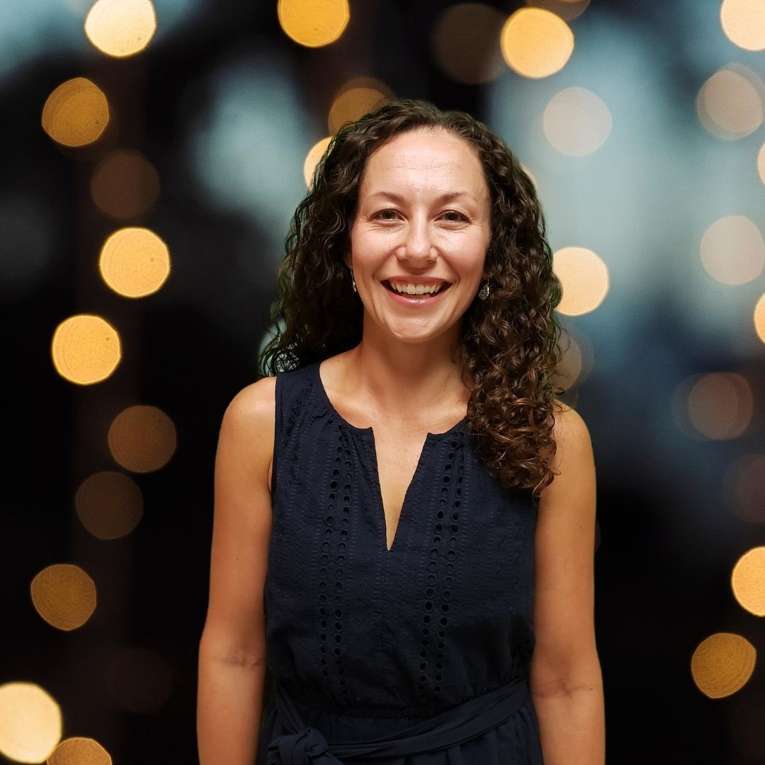

M. Ed Liberty University, NCC
Ms. Brandi Carlton has resided in Williamsburg, VA for 15 years, and is a graduate from Huntingdon College with a Bachelor’s in Elementary Education and Master of Education Degree from Liberty University. Brandi has over 17 years as an educator, serving as an Elementary Teacher prior to her current role as a School Counselor.

Brandi is dedicated to helping clients achieve their full potential, by developing their sense of identity and setting achievable goals. Her approach is rooted in compassion, respect, and practical strategies that empower clients to navigate false truths, find inner peace with previous struggles, and build confidence in themselves and future achievements. Brandi has provided exceptional care in the school setting working closely with parents and students, to determine roadblocks to students’ successes, as well as support for young adolescents navigating transitional stages in attending higher education and beyond.
Over the years, she has worked with early adolescent and college-aged individuals, providing support and a sense of ownership as individuals navigate pivotal moments of their lives. She believes every client, with empathy and encouragement, can achieve their counseling goals as they better understand their own identity.
Her goal is to provide a safe, nonjudgmental space where each voice is heard and valued. She tailors her support to fit your unique needs, blending evidence-based practices with a warm, collaborative style.
When not in session, she enjoys spending time with family, cooking, singing, as well as being outdoors.
If you’re ready to begin a journey to uncover your full potential and work through false beliefs you’ve held onto for too long, call our office to book a session with Brandi, she looks forward to walking alongside you.

